Hollis Summer Recreation 2018 BASIC Summer Schedule
Monday | Tuesday | Wednesday | Thursday | Friday
7/2  Day @ Rec | 7/3  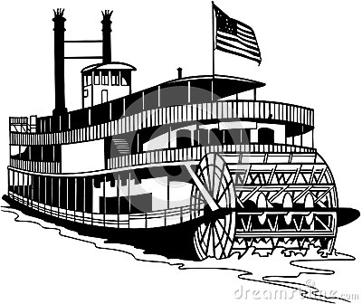  Songo River Queen | 7/4  NO REC  Happy 4th of July! | 7/5  Kiwanis Beach  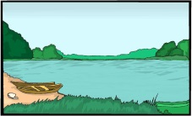 | 7/6  Fort Williams  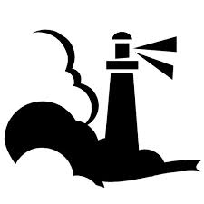
7/9  Dundee Park | 7/10  Big 20 Bowling | 7/11  Day @ Rec | 7/12  Pleasant Point  And Ice Cream | 7/13  Sebago Lake State Park
7/16  Kiwanis Beach | 7/17  Holdsworth Park | 7/18  Bradbury State Park  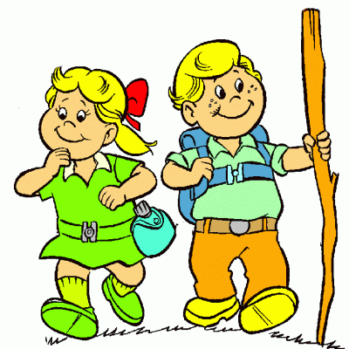 | 7/19  Day @ Rec | 7/20  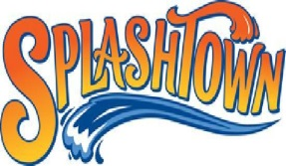
7/23  Bar Mills  Cookout  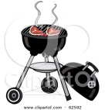 | 7/24  Cascades Walk and Ice Cream | 7/25  Pine Point Beach  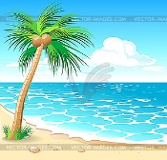 | 7/26  Mt. Agamenticus | 7/27  Happy Wheels  And Riverbank 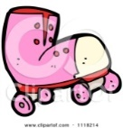Park
7/30  Spring Point Light House | 7/31  Holdsworth Park | 8/1  York Animal Kingdom | 8/2  Pine Point Beach | 8/3  Dundee Park  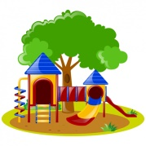
8/6  Fort Williams | 8/7  Range Pond State Park | 8/8  Day @ Rec | 8/9  Douglas Mountain  Hike | 8/10  Sebago Lake State Park
8/13  Holdsworth Park | 8/14  Day@ Rec | 8/15  Portland Trip  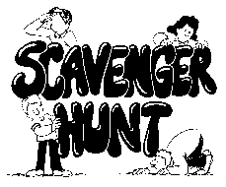 | 8/16  Pine Point Beach | 8/17  Family Day  @ Kiwanis

