Hollis Recreation
Summer Rec 2018
July 2nd – August 17th

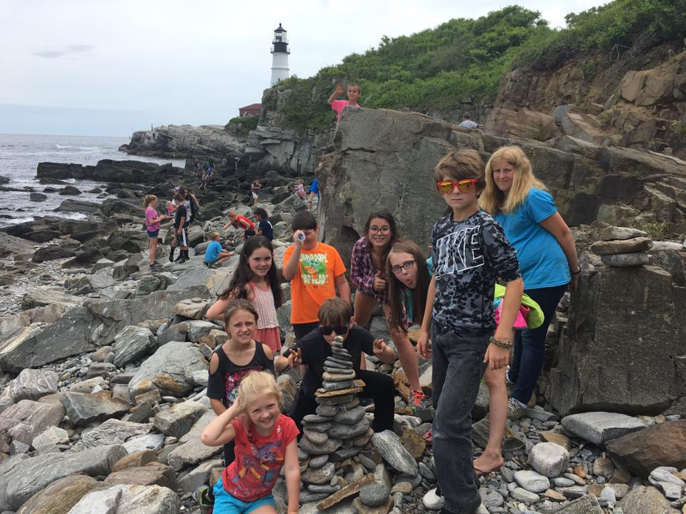Is your child ready for 7 weeks of nonstop fun and adventure? Our summer rec program offers daily field trips, games, crafts, entertaining age-appropriate theme days, and an overall experience they will never forget. Our camp is a seven week program with two groups; Our Basic group for children entering kindergarten up to 4th grade, and our Explorer group for children entering 5th grade up to 10th grade. Our regular hours of camp run from 8am to 3pm, and we offer an early drop off program from 6:30am- to 8:00am and a late pickup program from 3:00pm to 6:00pm
Basic Group (K-4th)
Home Base: Hollis Elementary Gym
Early Drop-off Location: Hollis Elementary Gym 6:30am- 8:00am $4/hour
Regular Drop-off Location: Hollis Elementary Gym 8:00am- 8:30am
Regular Pickup Location: Hollis Elementary Gym 3:00pm- 3:10pm
Late Pick-up Location: Hollis Elementary Gym 3:10pm- 6:00pm $4/hour
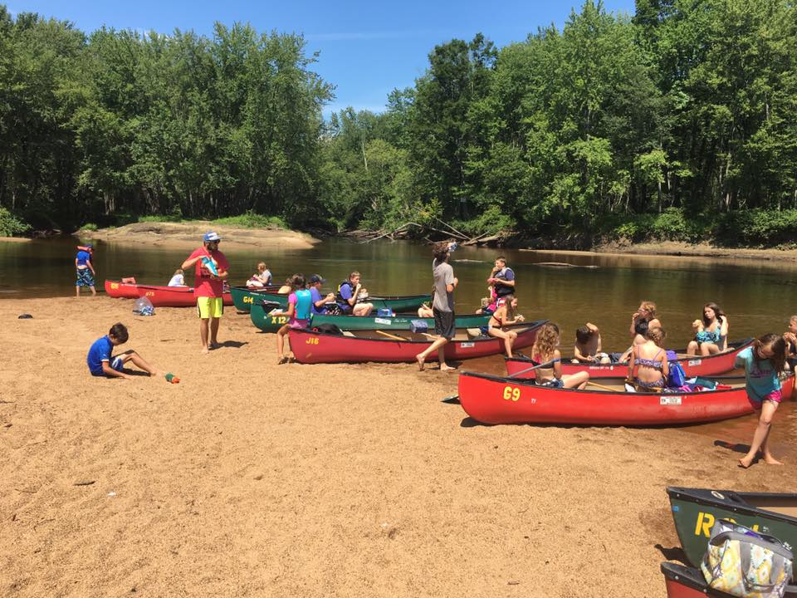Explorer Group (5th-10th)
Home Base: Hollis Sports Complex
Early Drop-off Location: Hollis Sports Complex 6:30am- 8:00am $4/hour
Regular Drop-off Location: Hollis Sports Complex 8:00am- 8:30am
Regular Pickup Location: Hollis Sports Complex 3:00pm- 3:10pm
Late Pick-up Location: Hollis Elementary Gym 3:10pm- 6:00pm $4/hour
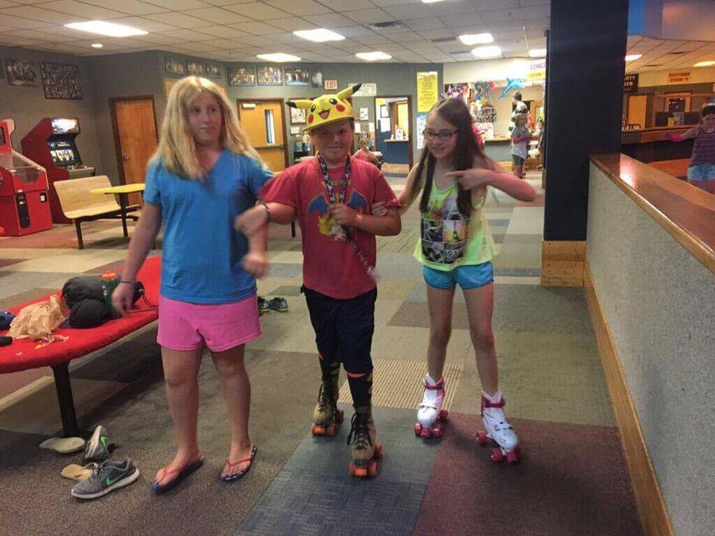Registration Information
Summer Rec registration is a first come-first serve basis. Each of the two camps has a participant maximum that is based on the maximum capacity for our buses. Please register ASAP

To register your children please fill out a registration packet. These can be downloaded from our website (http://www.hollismaine.org/parks-recreation), picked up from our office, or picked up from one of our official registration nights at the community building listed below. If your child needs to take any kind of medication during the day, please fill out the Medical release form as well. The fee does not need to be paid in full at the time of registration, but must be paid in full before 5pm on Friday, June 29th.

Basic Summer Rec Fee
1st child $630.00 Early Drop-Off $4.00/hour
Every additional child $605.00 Late Pick-Up $4.00/hour
Explorer Summer Rec Fee
1st Child $650.00
Every additional child $625.00

Visitor (Weekly Fee) $155.00 Out of Town Fee $35.00 (once per family)

REGISTRATION DATES:
-Monday May 7th 5:00pm – 6:30pm @ the Hollis Community Building
-Monday, May 21st 5:00pm – 6:30pm @ the Hollis Community Building
-Monday, June 4th 5:00pm – 6:30pm @ the Hollis Community Building

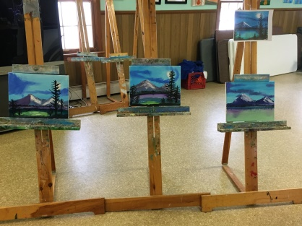
SUMMER DRAWING CLASS- There will be drawing classes on Thursdays at the Hollis Elementary School gym from 3:00 PM – 5:00 PM. The program starts Thursday, July 5th and ends Thursday, August 16th. The fee is $28.00, or $4.00 per class

SUMMER OIL PAINTING CLASS – The oil painting clinic will be held on Tuesdays from 3:00 pm–5:00 pm at the Hollis Elementary School gym. Participants will complete at least two paintings in this class. The clinic starts Tuesday, July 3rd. Other dates: 10th, 17th and 24th, 31stand August 7th, 14th. The fee is $49.00 or $7.00 per class.
Summer Policies
-Drop-off and pick-up: Our early drop-off and late pick-up programs are billed weekly at $4.00/hour in 15 minute increments. If you have children in both of the groups please go to the Sports Complex pick-up first. The late bus leaves from the sports complex at 3:10pm and if your child rides over to the community building you will be charged for the time.

-Notes for pickup: Your child must have a written note if they are going to be picked up from the program by anyone that is not specified on your child’s registration form. If your child is going to be walking or riding home from the program, please provide a note on the first day giving them permission to do so for the summer.

-WHAT TO BRING: your child should bring a lunch, plenty of water (at least 3 bottles on hikes), snacks, a towel, bathing suit, and sunscreen EVERY DAY. Even if our schedule does not specify swimming we usually try to swim somewhere or get wet every day. There are certain trips when snacks may be available for purchase, but your child should still bring lunch/snacks in case plans change. Some of the concession stands we visit have been closed randomly in the past. A change of clothes and a sweatshirt are always good thing to have at rec. especially on beach days. There is always a good chance you might end up getting soaked or dirty at rec.

-WHAT NOT TO BRING: Electronics, toys, playing card, etc. Electronics are allowed to be used during the regular rec day, and have a high chance of being damaged even if they stay in your child’s backpack. Our staff has phones available if your child needs to make a call. Hollis recreation staff is not responsible for any personal property that is lost, damaged, or stolen while your child is at rec.

-MONEY: There are certain trips when we will ask your child to bring money for things like ice cream, a concession stand, or to buy a souvenir. Please send your child’s money in a zip lock bag with their name on it. They are welcome to give it to a counselor to hold on to and keep track of.

-Late Pick-up: We offer a concession stand for snacks and drinks during late pickup. We require a note giving your child permission to buy snacks/drinks from us, as the concession stand includes soda and candy.

